https://github.com/WilliamQ28/IAT360-Final-Project
IAT 360 Final project report
ZhongJun Qian 301541827

Contents
1. Problem and context 1
2. Model choice, access, and licensing 2
3. RAG data: collection, cleaning, and bias 3
4. Application design and deployment 3
6. Future improvements 5

1. Problem and context
This report describes the NLP component of the IAT 339 project. The larger system uses a Wave Function Collapse (WFC) engine to procedurally generate banded web layouts from a dataset of annotated sites. The NLP module fills those layouts with a site name, hero copy, and section-level content, so the generated pages look like plausible product or service sites rather than blocks of lorem ipsum.
The aim here is not general conversation, but rapid MVP and vertical-slice prototyping. Given a content type (for example, “tech company” or “fintech”) and some high-level parameters, the module proposes a brand-style site name, generates a hero title and subtitle, plans several main sections, and writes concise paragraphs for each section. A retrieval-augmented generation (RAG) approach is used rather than a pure prompt-only model, so the model is at least loosely anchored to patterns found in real websites.
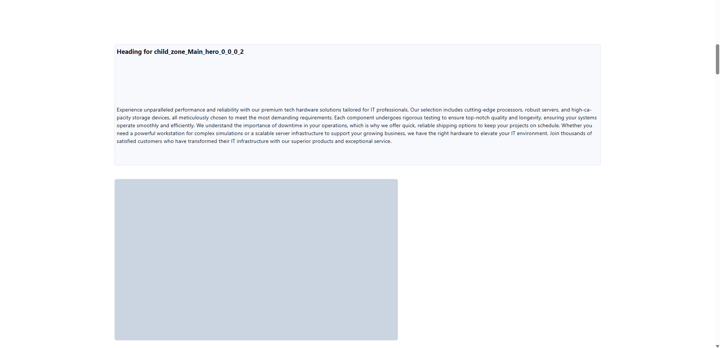
Figure 1: Successful hero-band usage. Generated heading and long paragraph text integrated into a WFC-generated hero layout with a large media tile.
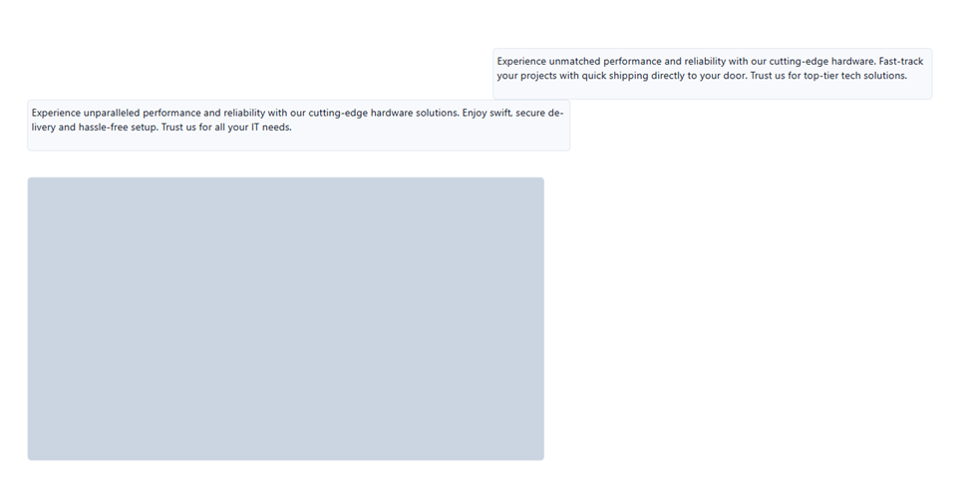
Figure 2: Successful card-style content usage. Shorter generated snippets placed above a single large media container in a different layout.
Figures 1 and 2 show examples of the module driving real layouts. In both cases the text generated by the NLP module drops cleanly into WFC-generated bands: the hero heading and long body copy sit above a large media tile in Figure 1, while Figure 2 shows shorter marketing snippets paired with a single large image block.

2. Model choice, access, and licensing
The module calls a hosted large language model via Hugging Face’s OpenAI-compatible /v1/chat/completions endpoint. I use Qwen/Qwen2.5-7B-Instruct as the default model. It is an instruction-tuned member of the Qwen2.5 family with about 7.6 billion parameters and long-context support; the Hugging Face model card describes it as a causal language model with improved instruction following and structured output, particularly JSON.
The model card and associated repositories state that Qwen2.5-7B-Instruct is released under the Apache 2.0 licence.
Access constraints also drive the choice of this particular model. With a free Hugging Face account and personal access token, Qwen2.5-7B-Instruct is one of the few instruction-tuned models that can be called reliably through the Hugging Face “Inference Providers” router. I do not host the model myself; the script sends HTTPS requests using the requests library, specifying the model ID and typical generation parameters such as max_tokens, temperature, and top_p.
I do not fine-tune the model. All adaptation for this task is achieved through prompt design and the RAG corpus.

3. RAG data: collection, cleaning, and bias
The RAG corpus is stored in rag_corpus.jsonl. Each line contains a short text snippet and metadata such as id, band, slot_type, source_url, topic, and text. The corpus was built by crawling a curated list of product and documentation sites, downloading HTML, and extracting visible text that resembles real web copy: hero headings, subtitles, and main-body paragraphs.
During extraction, I remove obvious noise such as navigation labels, cookie banners, and legal footers. Extremely short strings, boilerplate policy text, and non-English fragments are filtered out. Domain names and obvious brand tokens are partially stripped from the text to reduce the chance that the model will echo trademarked phrases verbatim. The result is a small but relatively clean collection of modern web copy fragments, mostly from English-language technology and service sites.
When gen_text.py runs, it loads this file and selects a few snippets to pass as “context” in the prompts. The selection can be purely random, or “topic” based, where records whose topic string matches the requested content_type are preferred. There is no embedding-based retrieval in this version; sampling is intentionally simple.
The main biases are straightforward. The data is English-only and heavily skewed toward contemporary SaaS and infrastructure marketing. Other domains, languages, and regions are either rare or absent. That means the generated copy tends to sound like a modern tech landing page regardless of the label. For this project, which itself focuses on phishing-style and product-like layouts, this bias is acceptable but limits generalisation.

4. Application design and deployment
The entire NLP module lives in a single Python file, gen_text.py. It exposes a command-line interface with two main modes.
In “staged” mode, the user specifies --sections N. The script first loads the RAG corpus and selects up to a fixed number of context snippets. It then generates, in order, a site name, a hero block, a section plan, and section bodies. The site name is produced by prompting the model for a short brand-style name based on content type, audience, tone, and context. The hero block is requested in strict JSON format with two keys: hero_title and hero_subtitle. If the returned string is wrapped in markdown fences or otherwise malformed, the script cleans and parses it, and if that fails, it falls back to line-based splitting.
For the section plan, the script asks for N headings with one-line intents and tries to parse the result as an array of objects. If parsing fails, it falls back to lines formatted as “Heading: intent”. Any missing entries are padded with generic “Section 1”, “Section 2”, and so on.
For each section, the body text is generated one paragraph at a time. A character budget per section is either taken from arguments or defaulted, then divided by the number of paragraphs. Each paragraph prompt includes the site name, section heading and intent, audience, tone, a target length, and instructions to avoid headings, lists, and placeholders. The prompt also passes a short “takeaway” sentence from the previous section and the first few words of earlier paragraphs in the same section, along with a note not to start with those phrases. Paragraphs that are too short, do not end on a sentence boundary, or repeat a banned opening are regenerated once with an adjusted prompt. The final output in staged mode is a nested JSON structure that includes the site name, hero, headings, intents, body paragraphs, the context snippets used, and the prompts that were sent.
In “single-box” mode, intended mainly as a legacy fallback, the user provides a width and height in pixels. The script estimates a character budget based on simple typography assumptions (font size, line height, and average character width), then constructs a single prompt and asks the model to generate cohesive body text that fits the box.
For marking, I expect the module to be run locally as follows (single-line command as required):
python gen_text.py --sections 4 --content_type "tech company" --tone "confident and clear" --audience "a general audience evaluating the offering" --token_file hf_token.txt --out output_staged.json
This produces a JSON file that can be inspected directly or used as input to the rest of the pipeline. To run the script, only a recent Python 3 interpreter, the requests package, a local rag_corpus.jsonl, and a Hugging Face token are required; there are no local ML dependencies because inference happens remotely.
5. Guardrails, bias, and limitations
The main guardrails are prompt-based and implemented via simple Python checks. For the hero block and section plan, I require JSON output and strip code fences and obvious formatting before attempting to parse. For paragraphs, I set target lengths, track opening phrases, and limit the number of retries.
These controls help but do not eliminate typical LLM artefacts. In some outputs, a paragraph includes fragments of the instruction text (for example, literally starting with “The previous attempt was incomplete or repetitive”), which is a form of prompt leakage. At the moment, I detect these issues by visually inspecting JSON outputs and adjusting prompts by hand when needed. A more robust system would include automatic detection of such phrases and force regeneration.
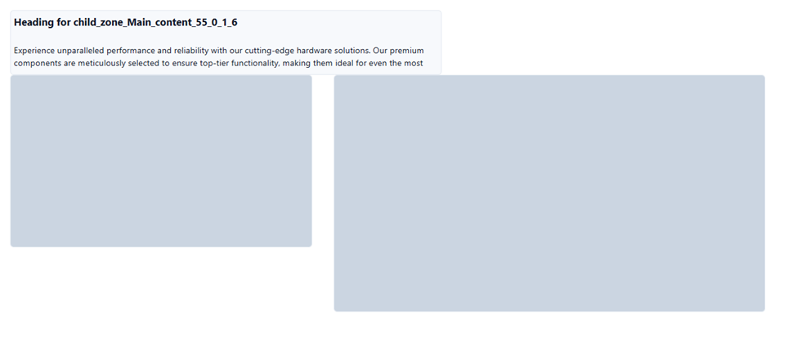
Figure 3: Example of a less successful configuration. Generic copy and heading compete with two large media tiles, illustrating a mismatch between generated text and layout, and failure in adherence to the character budget.
A practical limitation is that I cannot currently gather much more debugging data or regenerate many full HTML pages through the entire pipeline. The free Hugging Face API key only provides around ten cents’ worth of credit, which is quickly exhausted when running the staged pipeline multiple times. That constraint caps how many seeds I can experiment with and how deeply I can probe edge cases and rare failures.
From an ethical standpoint, the model itself is open-licensed, and the RAG snippets are used for internal academic work in short fragments, with brand terms partially removed. The bigger concern is bias: the corpus over-represents a particular style of English-language tech marketing, and the system reproduces that style. I do not claim that the generated copy is suitable for other domains or languages. The module is framed explicitly as a design and prototyping tool within this narrow scope.

6. Future improvements
If I had more time and a larger API budget, I would prioritise two improvements.
The first is a multimodal extension. The staged pipeline already includes the site name, section headings, intents, and body text for each section. These fields are enough to drive an extra step where the model generates a short image description for each section, for example, “three people in a modern office looking at charts on a laptop.” Those descriptions could be sent to an image generation service or an image search API and then slotted into the WFC layout where image bands occur. This would turn the system into a more complete procedural website generator with both text and images.
The second is systematic logging and hallucination tracking. Currently, I only look at individual JSON outputs when debugging. A script would be to log every run into a local JSONL file, recording input arguments, selected RAG snippets, all prompts, raw model outputs, and cleaned outputs. That log would enable searching for recurring problems, such as prompt-leakage phrases, and designing simple automated checks.
Beyond that, there is room to improve the RAG corpus and retrieval. Adding more varied domains and languages, and moving from random or topic-based sampling to an embedding-based retriever, would make context selection more meaningful. Tighter integration with the WFC pipeline also allows character budgets and paragraph counts to be derived directly from the actual sizes of text bands in the layouts, so that text density more closely matches the generated design.

